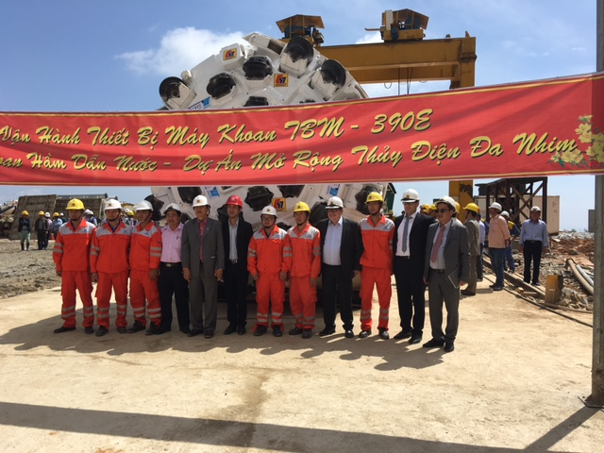**F**ebruary 6th 2017, CREG R73 hard rock TBM has been successfully launched in Vietnam Da Nhim jobsite. CREG as a TBM manufacturer pioneer, vigorously promoted the development of infrastructure construction in this country.

***CREG R73 hard rock TBM is ready to go in Vietnam***

In November 2015, CREG was committed to renovate and refurbish a used Wirth hard rock TBM for Vietnam hydroelectric power station project running by CC47 Company. After elaborate studying, modification and testing, CREG professional team has achieved their goal that the hard rock TBM’s performance met all the requirements according to the local geological condition. Factory acceptance was took place in Oct. 2016.



The TBM main characters are as follows:

* TBM Length: approx. 170 m
* TBM type: gripper TBM
* Boring diameter: 3,90 m
* Motorization: Electrical drive
* Total installed power: 1440 kW
* Max. advance speed: 6m/h
* Max. torque: 1400 kN∙m
* Rotation speed: 0 to 12,5 rpm

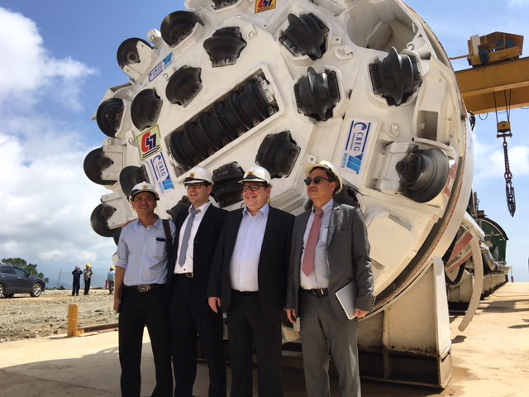

Kelly system is consisting of cutter head jacket, support ring, support cylinder, push cylinder, Kelly gripper and rear support.

Key features are as follows:

* Gripper pads: 8 units
* Gripper cylinder: 16 units
* Total gripping force. 19968 kN
* Thrust cylinder: 2 units
* Max. thrust force: 8048 kN

